Modes in Optical Fibers

Experiment 1: Coupling light into a multi-mode fiber and observing output beam profile.
Experiment 2: Observing intensity pattern of the fundamental mode and measuring the
mode field diameter in a single-mode fiber.
Experiment 3: Observing the allowed modes in the slightly multi-mode fiber.

I. Introduction:

The allowed distribution of electromagnetic fields across the fiber is referred to as the modes of the fiber. Generally a mode in an optical fiber is represented as LP_{mn.}
LP stands for linearly polarized modes
m represents number of variations along azimuthal direction
n represents number of variations along radial direction

I.1. Preparation of the fiber:

- Remove the outer buffer using mechanical stripper.
- Clean the removed buffer area with IP solution.
- Cleave the fiber end in order to obtain a flat end-face. This will reduce the scattering loss while coupling light into the fiber.

I.2. Cleaving operation:

Cleaver works on the basis of scribe and break technique, illustrated in Fig.1. The carbide blade is used to start a small crack in the fiber. Stress is evenly applied by pulling the fiber, causing the crack to propagate through the fiber and resulting in a cleave across a flat cross section of the fiber perpendicular to the fiber axis.

Pull
Fiber
Carbide blade
Tip to crack propagates
As fiber is pulled
Pull

Fig.1. Scribe and break technique of fiber cleaving

I.3. Experimental setup:

HeNe laser (633 nm)
Fiber coupler
with 20X lens
Fiber coupler
with 20X lens
Photo diode
Power meter
Laser beam
Transmitted laser beam
Fiber

Fig 2. Experimental setup

- Mount the He-Ne laser and the fiber coupler with 20X objective lens, so that the laser beam is parallel to the lens axis and strikes the lens at the center.
- Strip and cleave the both ends of the fiber. Be sure not to make any contact with the fiber end after cleaving.
- Mount the ends of the fiber in the fiber holder, insert into fiber coupler and tighten the knob at the end of the fiber coupler.
- Keep the input fiber end nearly to the focal point (approx. 8 mm from the lens) and the output fiber end close to the lens to get a sharp pattern.
- Bring the input end of the fiber into focal plane of the objective lens by rotating the coarse adjustment knobs on the positioner of the coupler. This will ensure the alignment of the fiber along the axial direction (along the direction propagation).
- Adjust the X and Y components of the fiber alignment using fine adjustment knobs on the tilt stage of the fiber coupler, to achieve the maximum coupling. The complete experimental setup is shown in Fig 2.

I.4. Optimizing coupling (Setting into focal point):

Microscopic objective lens is used to focus the collimated beam from the laser to a small spot. The diameter of the spot size d₁(shown in Fig 3), of the focused laser beam can be

d₁ = 4Λ f / 3.14d

where d may be found by the divergence of the laser
f focal length of the microscopic objective lens.

The diameter of the laser beam incident on the lens can be determined by

d = d_{o}*(1+(zΦ+d_{o})²)^{1/2}

where Φ is the angle of divergence ( ≈1.3 mrad)
z is the laser to lens distance.

d₁ is otherwise approximately given by, d₁ = 2a [.65 + 1.619/V^{1.5} + 2.879/V⁶]
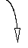
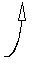
Laser
Lens
d_{o}
d
Φ
d₁
Focal point
Fiber
Fig 3. Determination of focal point
I.5. Checking the focal point:

One of the key challenges in coupling light into a single-mode fiber is to find out the focal plane of the lens. In order to simplify this, place a microscope glass slide at and angle 45 degrees with respect to the beam path between laser and lens. Observe the light beam reflected from the front face of the fiber as you bring the fiber closer to the focal plane. At the focal point, the light coming from the laser and the light reflected from fiber end have same diameter.

II. Experiment 1:

II.1. Property of the multi mode fiber:

Radius of the core, a = 30µm
Wavelength of HeNe laser, Λ = 633nm
Numerical aperture, NA = .11
V number, V = K_{f} . a . NA
= 2*3.14/Λ .a. NA
= 32.75
Number of the modes it can support, M ≈ V²/ 2
≈ 536.

In this experiment we have to couple light into the multi-mode fiber and observe the maximum intensity of the light at the output using a power meter. In the intensity pattern, we are unable to visualize any particular mode since the fiber supports a huge number of modes.

III. Experiment 2:

III.1. Property of the single mode fiber:
Radius of the core, a = 2µm
Wavelength of HeNe laser, Λ = 633nm
Numerical aperture, NA = .11
V number, V = K_{f} . a . NA
= 2*3.14/Λ .a. NA
= 2.18
The mode supported by the fiber is the fundamental mode LP ₀₁ whose intensity pattern is illustrated in the Fig 4.

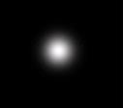

Fig 4: LP ₀₁

III.2. Observing the intensity pattern of fundamental mode:

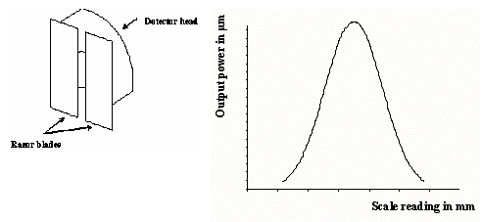
Fig 5ii: Intensity pattern of a SMF
Fig 5i: Taking splices of intensity pattern

The intensity pattern illustrated in Fig 5ii is drawing by taking small splices of the output and measures its intensity using power meter. Two razor blades taped together with spacing about 1-2 mm between the blade edges make a good mask as shown in Fig 5i.

III.3. Calculation of Mode Field Diameter (MFD):

MFD is a measure of distribution of optical power intensity across the end face of a single mode fiber as illustrated in Fig 6. It is theoretically given by

MFD = 2a [.65 + 1.619/V^{1.5} + 2.879/V⁶]
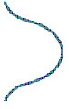
Po
Po e⁻²
Core
Cladding
Fig 6: Pattern inside the fiber
For practical calculation, calculate the length where the intensity is reduced by e-² from its peak value, named it as MFD₁.

MFD = MFD₁ / Magnification factor

Magnification factor = Power of the lens * Distance between lens and observation point/
Distance between lens and fiber

IV. Experiment 3:

IV.1. Property of the slightly multi mode fiber:

Radius of the core, a = 4µm
Wavelength of HeNe laser, Λ = 633nm
Numerical aperture, NA = .11
V number, V = K_{f} . a. NA
= 2*3.14/Λ .a. NA
= 4.367.

For a fiber with a V number of 4.367, it can support 4 modes as illustrated by the graph V- number Vs propagation constant (Fig 7).

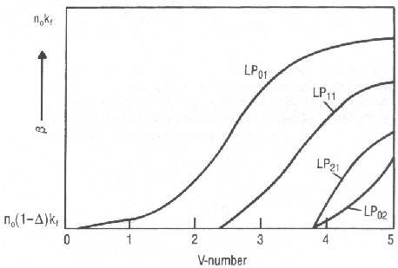

Fig 7: V-number Vs Propagation constant ( β)

The modes allowed are shown in figure below ( Fig 8).

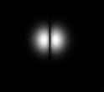
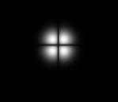
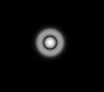

Fig 8: Modes in a slightly multi mode fiber

In this experiment, we are supposed to optimize the coupling such that we observe the LP₀₁ mode. After this, deliberately misalign the coupling such that one of the higher order modes is excited. Roughly trace the patterns in the report.

