Attenuation and Pulse Broadening in a Fiber Optic Link

In this experiment, we will learn how to characterize the attenuation and pulse broadening in a fiber optic link. We will use a plastic optical fiber for this experiment since it is rugged and cheap. Plastic optical fiber has the highest attenuation among the optical fibers. Plastic optical fibers have a thick plastic core and cladding. Their typical dimensions in microns are 480/500, 735/750, and 980/1000. Such large core diameters facilitate coupling light into them relatively easily. The core generally consists of poly-methylmethacrylate (PMMA) coated with a fluropolymer.

I. Attenuation:

Characterization of attenuation in a fiber optic link will consist of three different experiments. These are

Measurement of attenuation at 650nm and 850nm wavelengths.

Measurement of bending loss as a function of bend radius.

Measurement of coupling loss between two fibers.

The experimental procedure is well explained in the Benchmark manual (Expt. #3).

II. Pulse Broadening:

In a fiber optic link using multimode fibers, the two dominant mechanisms limiting the transmission bandwidth are (1) intermodal dispersion and (2) receiver bandwidth. In this experiment, we will characterize these pulse broadening mechanisms.
II.1. Intermodal Dispersion:
Intermodal dispersion is the dominant source of dispersion in multimode fibers. In a multimode fiber, the input light pulse can excite a group of modes. As the modes propagate along the fiber, light energy distributed among the modes is delayed by different amounts. The pulse spreads because each mode propagates along the fiber at different effective speeds. This may be understood through a ray picture. The modes of an optical fiber travel in different paths, with the fundamental mode traveling parallel to the fiber axis and the higher order modes traveling with steeper angles with respect to the fiber axis. As such, modal dispersion occurs because each mode travels a different distance over the physical span, as shown in figure 1. The modes of a light pulse that are excited in the fiber simultaneously exit the fiber at different times. This condition causes the light pulse to spread. As the length of the fiber increases, the pulse spreads more.
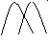
Core
Cladding
Cladding
Modes excited
at the same time
Modes exit
at different time

Figure 1 - Distance traveled by each mode over the same time span.
The experimental procedure is as follows:
- Put the switch SW8 in the digital position. Ensure that the shorting plug of the jumper JP2 is across the posts B & A1 (for PD1 selection).
- Take the 1m fiber and setup a digital link using LED1 in the optical TX1 block and detector PD1 in the optical RX1 block (850 nm link).
- Drive a square waveform of peak to peak 1 volt with zero dc at PXX. Observe the signal at P31 on the oscilloscope.
- Replace the 1m fiber by the 8m fiber between LED1 and PD1. Again note the waveform at P31 on the oscilloscope.
- Observe the difference between the pulse shape among the waveforms.

II.2. Pulse broadening due to receiver capacitance:

The pulse broadening and the limitation in bandwidth can also be affected by increasing the capacitance across the PIN diode, thus affecting the RC time constant of the receiver. The pulse broadening may cause overlapping of neighboring pulses. To avoid this pulses have to space apart. This implies a reduction in the number pulses or bits transmitted per second and hence the limitation in the bit rate of the signal.

The objective of this experiment is to demonstrate the effect of pulse broadening on the bandwidth of a communication link.
The experimental procedure is as follows:
- Put the switch SW8 in the digital position. Ensure that the shorting plug of the jumper JP2 is across the posts B & A1 (for PD1 selection).
- Take the 1m fiber and setup a digital link using LED1 in the optical TX1 block and detector PD1 in the optical RX1 block (850 nm link).
- Drive a square waveform of peak to peak 1 volt with zero dc at PXX. Observe the signal at P31 on the oscilloscope and note the rise time and fall times of the signal.
- Connect a 15pF capacitor between the PD1 output post p32 and the adjacent ground post. Again observe the rise time and fall time of the signal.
- Repeat the step 4 for various values of C_{EXT} (namely 47 pF, 100 pF, 150 pF, 220 pF, 33o pF, 470 pF, 560 pF & 680 pF). The rise and fall times are to be noted down and tabulated. Are you able to get the digital reception and operate for all values of C_{EXT}.
- It is not possible to get a lock condition for higher values of C_{EXT} as it is difficult to detect 1’s and 0’s correctly.
- Compute the 3 dB bandwidth for each value of C_{EXT} used in the experiment. The 3 dB bandwidth of the receiver is given by
f_{3dB} = 1/ (2*3.14*RC)

II.3. Observing eye pattern and observing how the eye closes as a function of C_{EXT}.
The eye pattern technique is a simple but powerful dispersion measurement method .The eye pattern method measurements are made in time domain and allow the effects of waveform distortion to be shown immediately on an oscilloscope.
Figure 2 shows the basic equipment setup for making eye-pattern measurements.
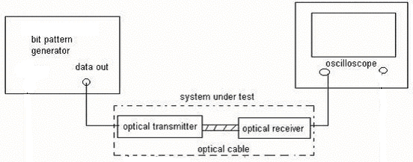
Figure 2: The basic equipment setup for making eye-pattern measurements
The following information can be derived from the eye-pattern:
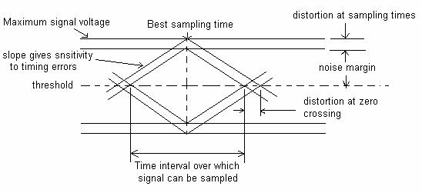
Figure 3: Simplified eye diagram showing the key performance parameters

1) Timing jitter (also referred to as edge jitter or phase distortion) in optical fiber system arises from the noise in the receiver and pulse distortion in the optical fiber. If the signal is sampled in the middle of the time interval, then the amount of distortion at the threshold level indicates the amount of jitter.
2) System rise time, rise time is defined as the time interval between the point where the rising edge of the signal reaches 10 percent of its final amplitude and the time it reaches 90 percent of its final amplitude.
3) The width of the eye opening defines the time interval over which the received signal can be sampled without error from intersymbol interference.
4) The best time to sample the received signal is when the height of the eye opening is largest. This height is reduced as a result of amplitude distortion in the data signal. The vertical distance between the top of the eye opening and the maximum signal level gives the maximum distortion. The more the eye closes, the more difficult it is to distinguish between ones and zeros in the signal.
5) The rate at which the eye closes as the sampling time is varied (i.e. the slope of the eye pattern sides) determines the sensitivity of the system to timing errors. The possibility of timing errors increases as the slope becomes more horizontal.
Observe the eye pattern for every value of C_{EXT} and observe how eye closes.

