Getting Started with KAVI-PTS

System Requirement:
Android OS: 2.3.3
Display: No limitation
Memory: 512 MB RAM
Disk space: 2 GB
Wi-Fi or USB: Required to download the application from the server

Installation:
You can install this application on Android device in two ways
- Download directly from link to the device
- Go to link https://
- You will find KAVIPTS.apk file. Click on it.
- KAVIPTS.apk will be downloaded to “Download” folder of device.
- Go to “Download” folder.
- Click on KAVIPTS.apk and then install the application. Accept the warning about installing apps from untrusted sources. As long as you avoid illegal sites and display the same common sense you use to protect your PC, you should be okay installing from trusted developers.

- Load from PC to USB device or SD card
- Download the KAVIPTS.apk file from https:// on PC
- Connect Phone/Tablet to PC through USB cable
- Copy KAVIPTS.apk to some folder on USB or SD card of Tablet/Phone
- Disconnect the device from PC
- Go to path where KAVIPTS.apk is copied
- Click on it and install.
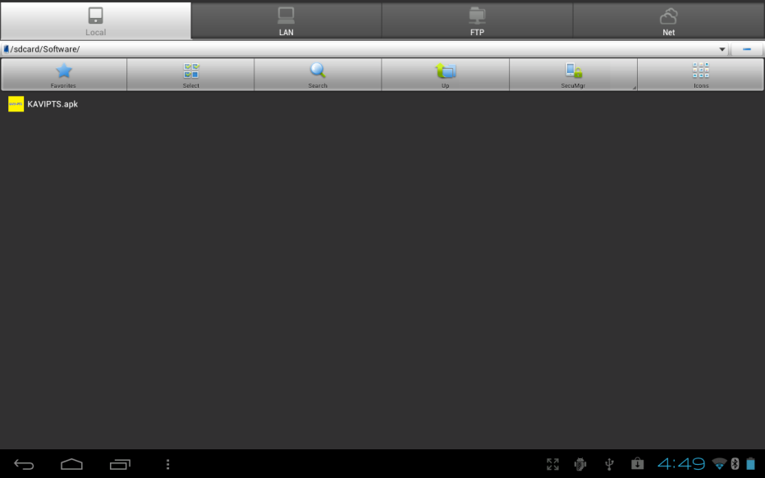
Figure 1
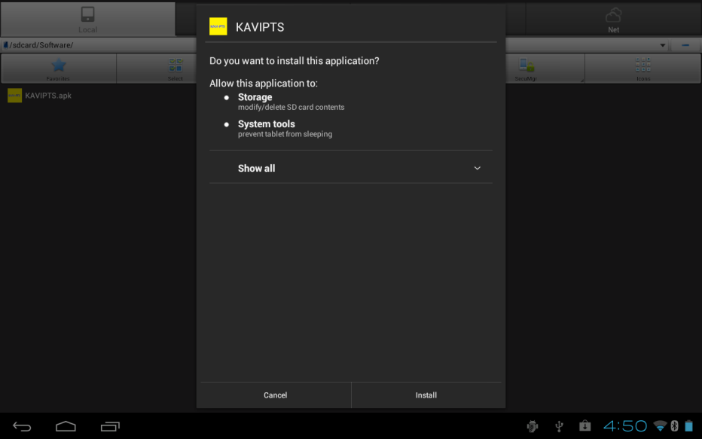
Figure 2
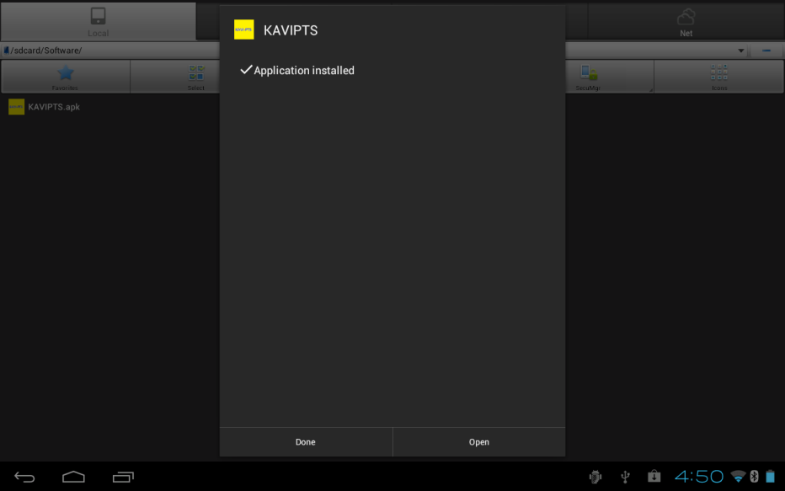
Figure 3

How to Launch KAVI-PTS on Device
To Launch the KAVI-PTS Application, user has to go to main menu of device. Here application icon KAVI-PTS will be displayed Click/Tap on it, this will launch the KAVI-PTS application. The application will be launched with default level (level 1). i.e only 4 items will be displayed . Application will work in Landscape and portrait mode.

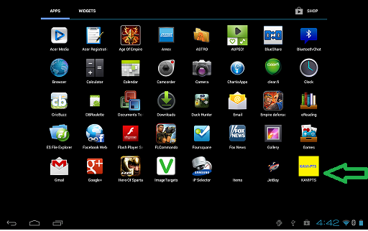
Figure 4
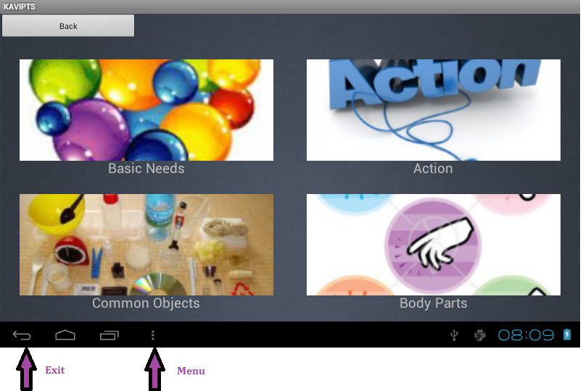
Figure 5

User can select Level 2 / Level 1 depending on kid’s age group.
Level 2 contains 10 items in grid view.
Go to Menu->Settings ->Level select level

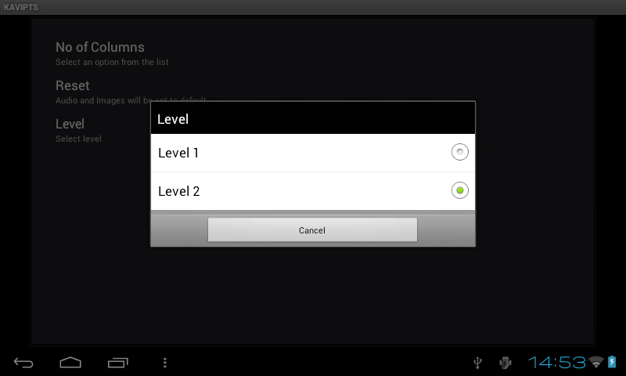
Figure 6
How to Stop KAVI-PTS Application
Application can be closed by pressing Back button on the footer of the device as shown in figure. If user is on second screen of the application then press back button twice to close the application.

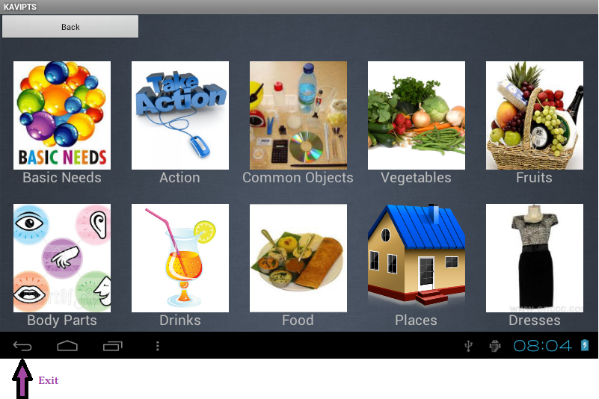
Figure 7

How to go back to previous screen
Every screen is provided with “Back” Button. By tapping on it user can go back to previous screen.

If user is on home screen, tap on back will close the application. If user is on any sub screen pressing back key will take user to home screen.

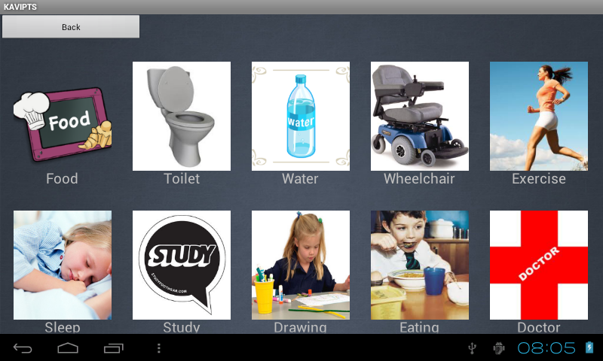
Figure 8

Functionality of the Application
The first screen that appears on application launch is called as the Main Screen / dashboard screen that contains 4/10 grid items depending on the Level selected. Each item represents a category like Basic Needs, Action, Common Objects, Vegetables, Fruits, Places, Dresses, Body Parts, Places, and Food

On pressing any of the items, an audible voice of what the category is, is played and a new screen is launched. The new screen contains 10 items in grid view related to main menu option. If user selects , next screen will display Idli / Dosa / Bread / Rice / Sambar / Rasam / Curds . . . Simply select the image you wish to say.

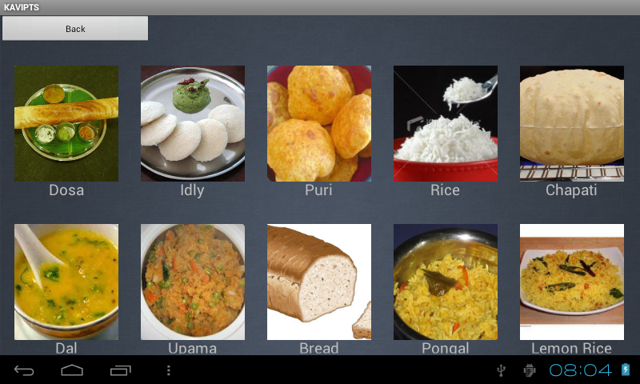
Figure 9

User Preferences
The User Preferences can be accessed by pressing the menu button on footer of Android phone and by selecting the “Menu” button shown in figure

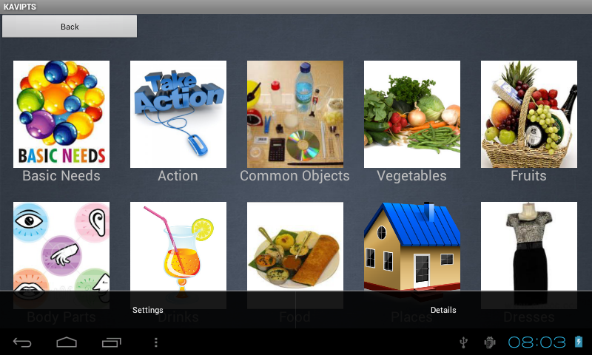
Figure 10
There are several options for various user preferences. The description of these screens and their contents are described below:

Application Settings:
Pressing Setting will allow the user to customize the application.
Selecting the “Settings” button shown in figure 4 User can select No of columns to be displayed on each screen as shown below

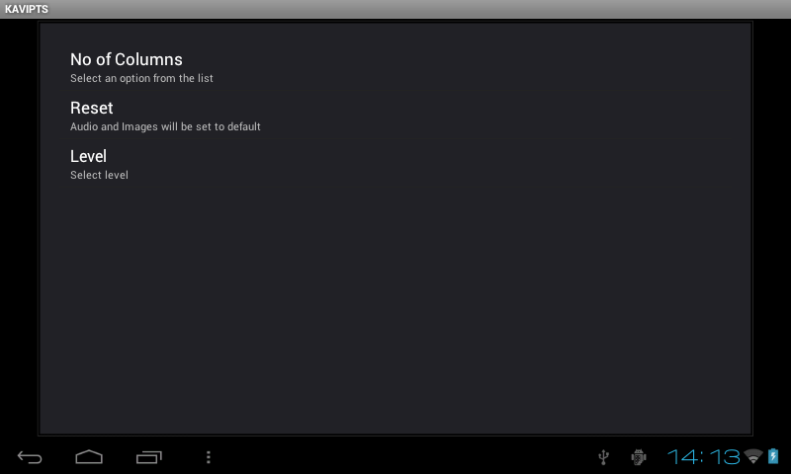
Figure 11

Tap on No Of Columns

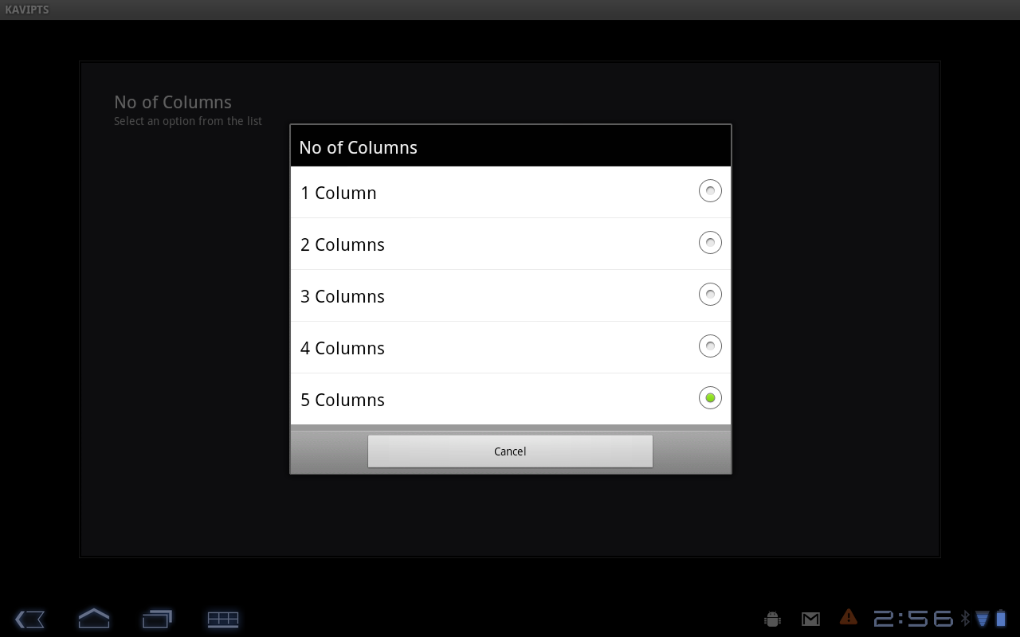
Figure 12

If User selects 1 Column only one item on the screen will be displayed and user can scroll Up and Down for more options on the screen.

Tap on Reset

If User selects “Reset” option from setting, all the data i.e. changed using “Add Voice”, “Add Picture” option will be reset to default.

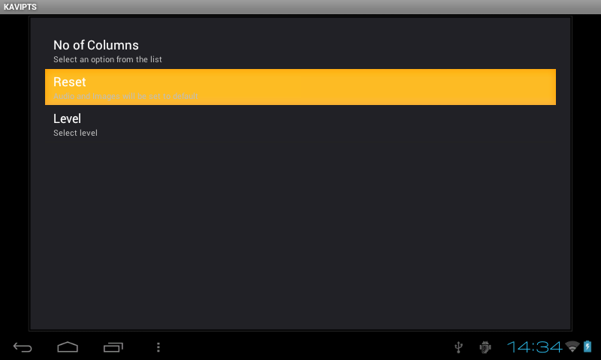
Figure 13

Tap on Level

If User selects “Level” option from setting, bellow screen will be displayed. This is done to for different age group of kids. For the kids in age group of 4-6 years level 1 can be used. And for higher kids level 2 can be used.

Figure 14
Application details:
Pressing Details Button as displayed in Figure 4 will display the details of the application (version name of application)
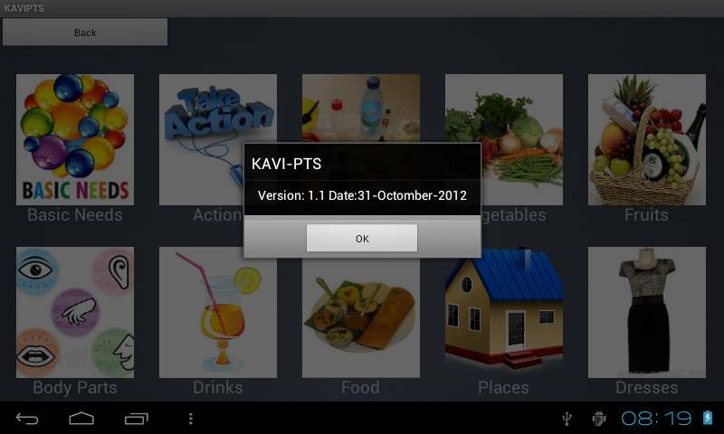
Figure 15

Customize Application for Picture ,Voice and Label:
You can customize the application by selecting different Pictures and Voice And Labels. This can be achieved by Hold and Press of any item which you want to customize. When you Hold and Press any item for few second below screen will be displayed.

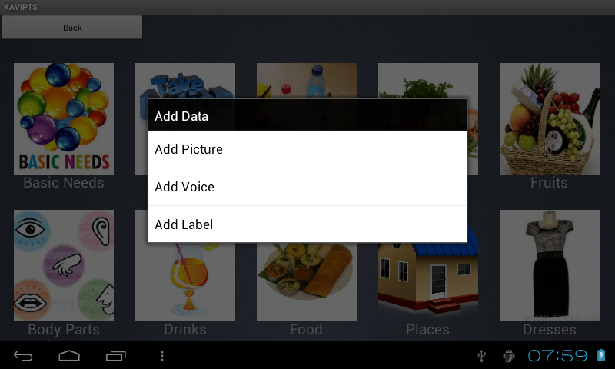
Figure 16
When Add Picture option is selected, it will root you to select any images from /mnt/sdcard/ folder. User can also store images needed for this application in mnt/sdcard/kavipts/pictures.

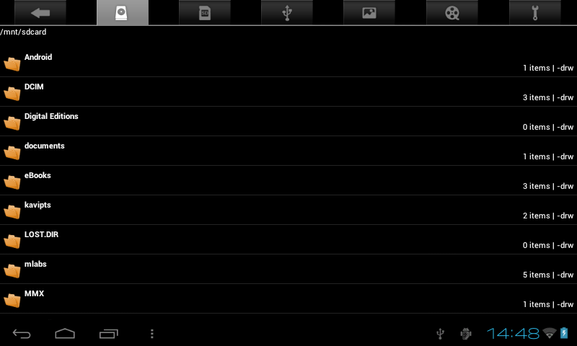
Figure 17

When Add Voice option is selected, it will root you to select any audio from /mnt/sdcard/ folder. User can also store audios needed for this application in mnt/sdcard/kavipts/audio.

Figure 18

When Add Label option is selected, it will display the text box dialog, where user can enter the label which he/she want to change. Once Set Label button is pressed it will replace the old label with new one.

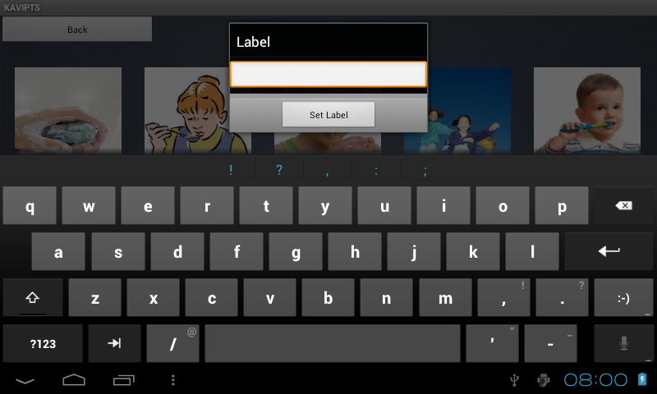

Backlight Mode:
By default device will have backlight setting set to few seconds to save the power/battery of the device. Since this application is designed for Autistic child to communicate between child and teacher/parents, it is better to ON backlight continuously. For this purpose Backlight is made continuously on when the application is running.
It is suggested to close the application when not in use to save the power/battery.
Voice Recording:
User can record his/her voice by any voice recording application present on device. Voice recorded will be stored at mnt/sdcard/recording path. These audio files can be used for “Add Voice” option.

